Problem Statement:
Identify the resources which are not compliant with the Organizational compliance rules.
Consider a scenario where as per your Organizational rules you want to identify the EC2 instances for which detailed monitoring has not been enabled
A Step-by-step guide:
- Navigate to AWS Config Service. Click on ‘Get Started’ if you are using AWS Config for the first time
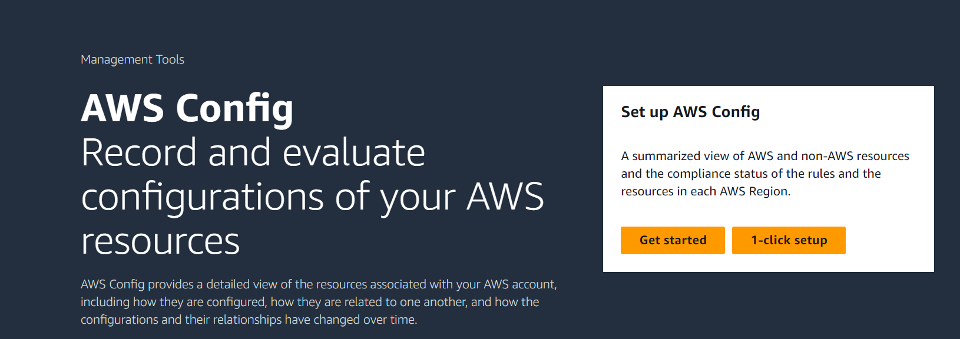
- Select to record just AWS EC2 Instance
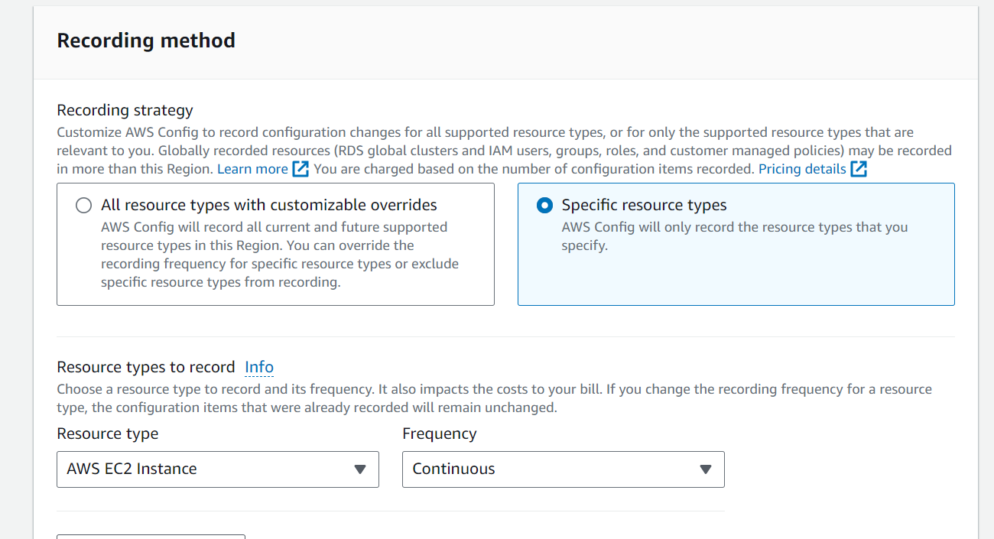

- Select IAM role for AWS Config and S3 Bucket name to store logs
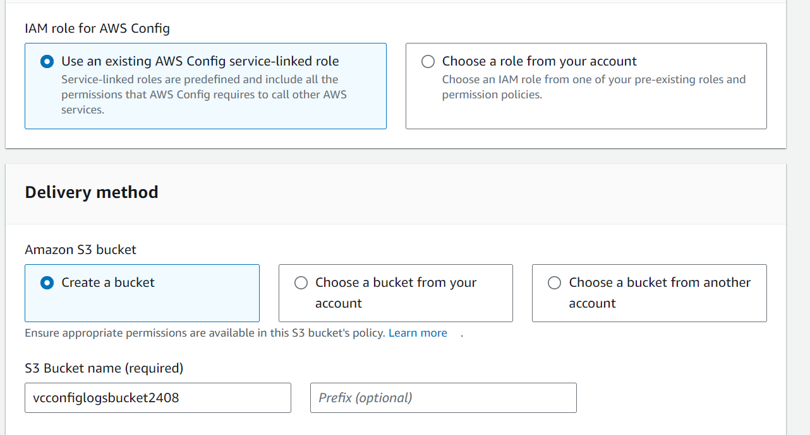
- Do not select any Managed Rules since we are going to create a custom rule
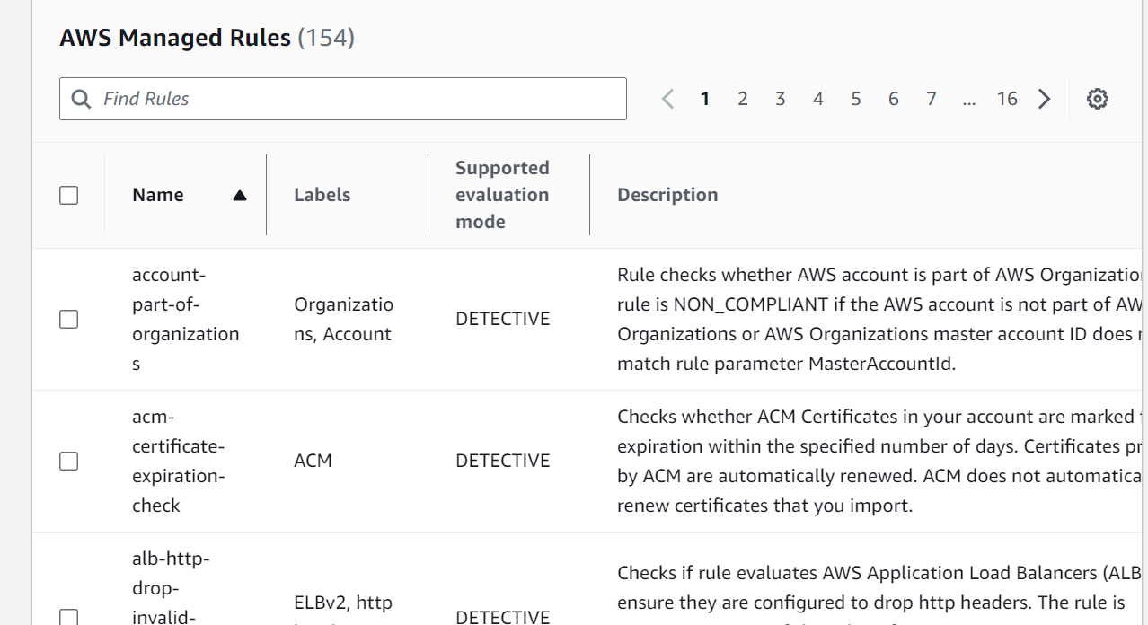

- Click confirm and enable AWS Config
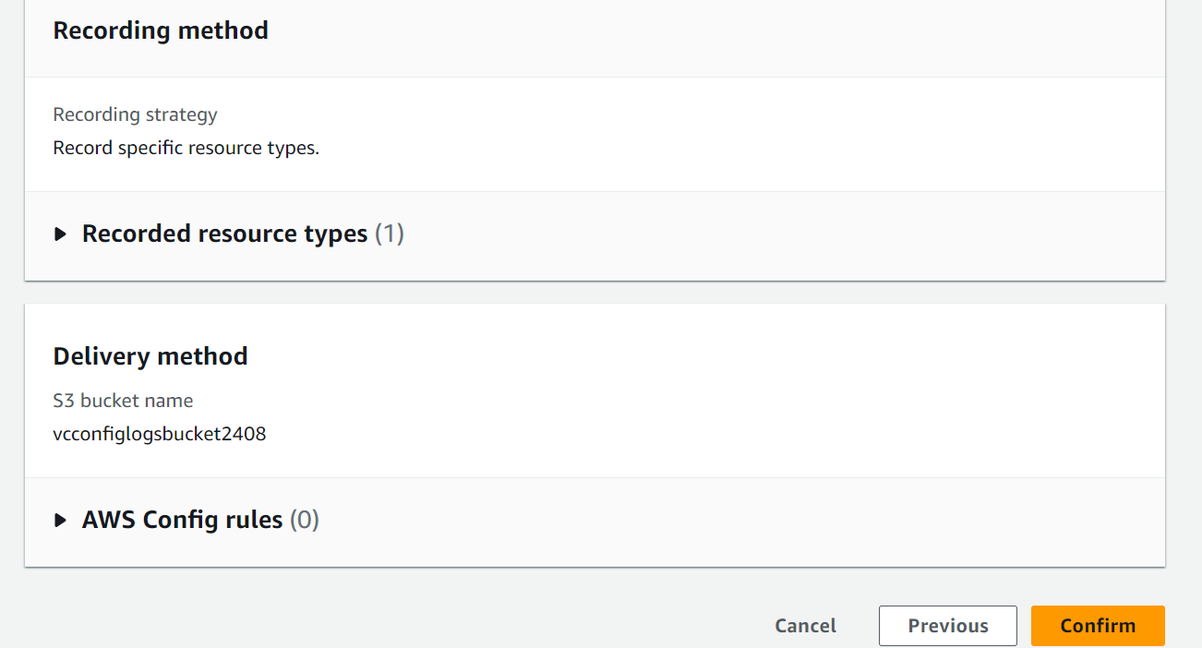
- Go to AWS config and go to Rules

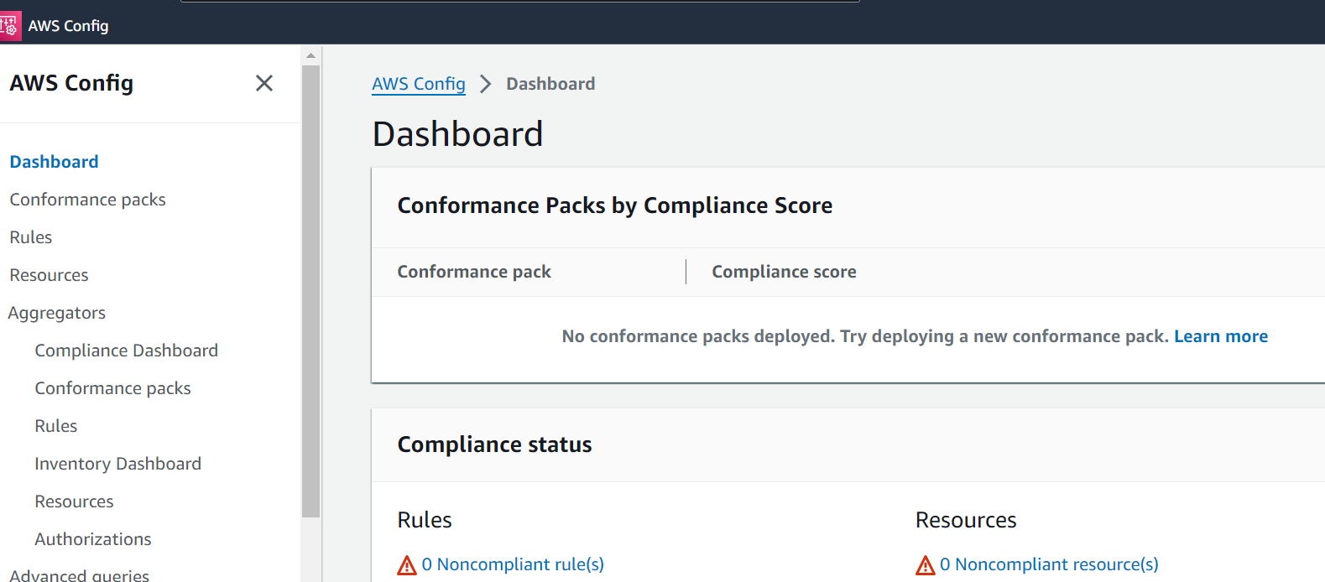

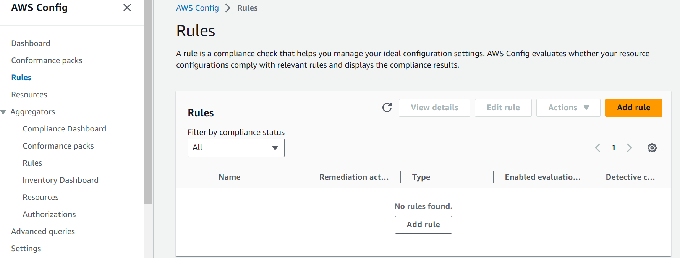

- Click on Add rule and select Add AWS managed rule. Search AWS managed rule for EC2
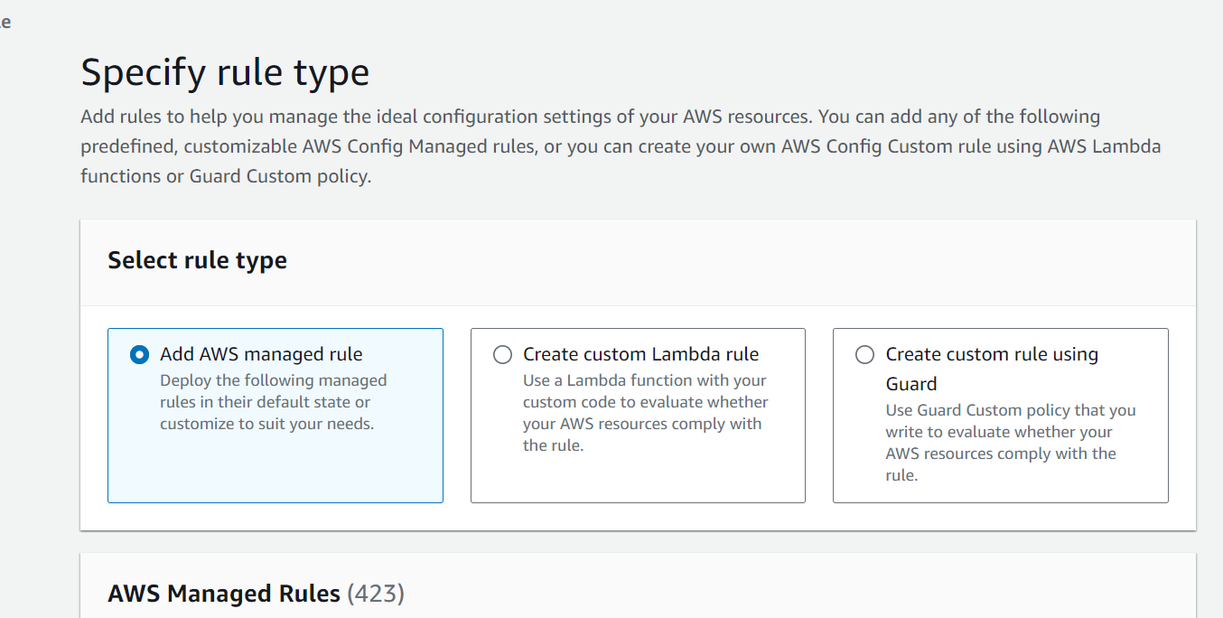
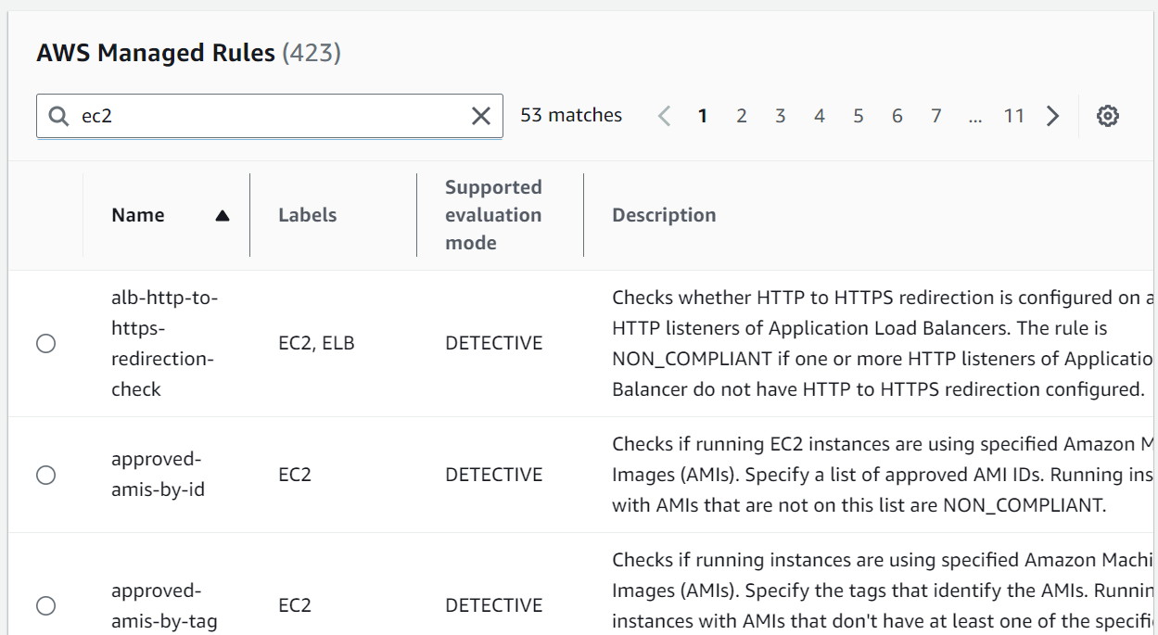

- Select ec2-instance-detailed-monitoring enabled to detect EC2 instances where detailed monitoring has been enabled or not
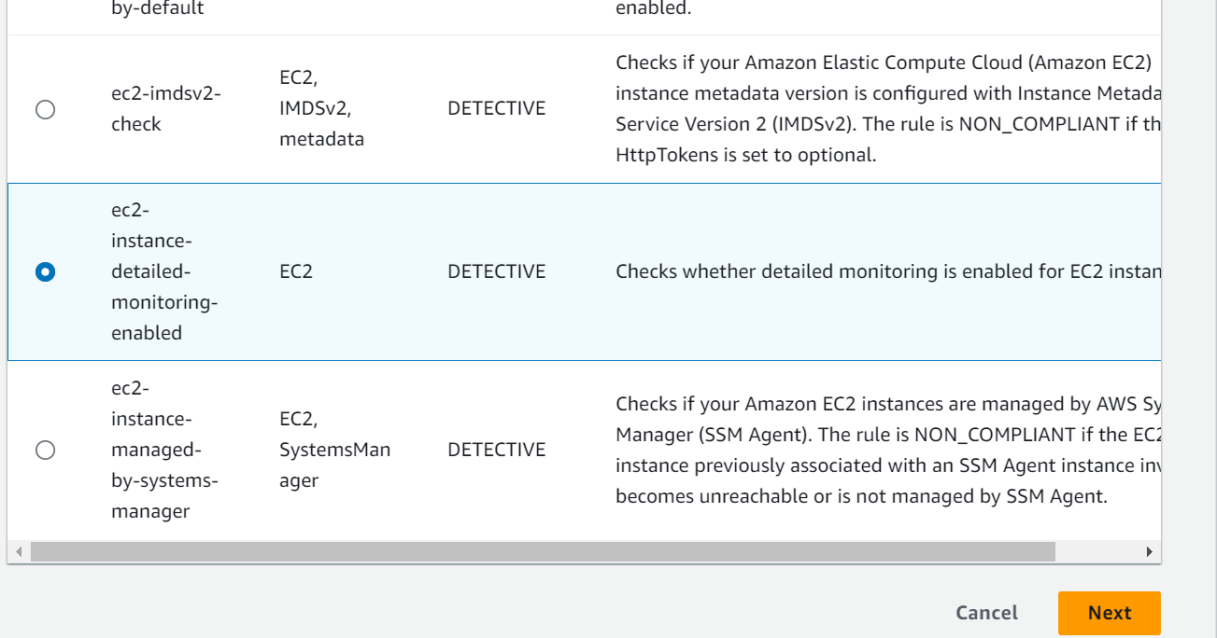
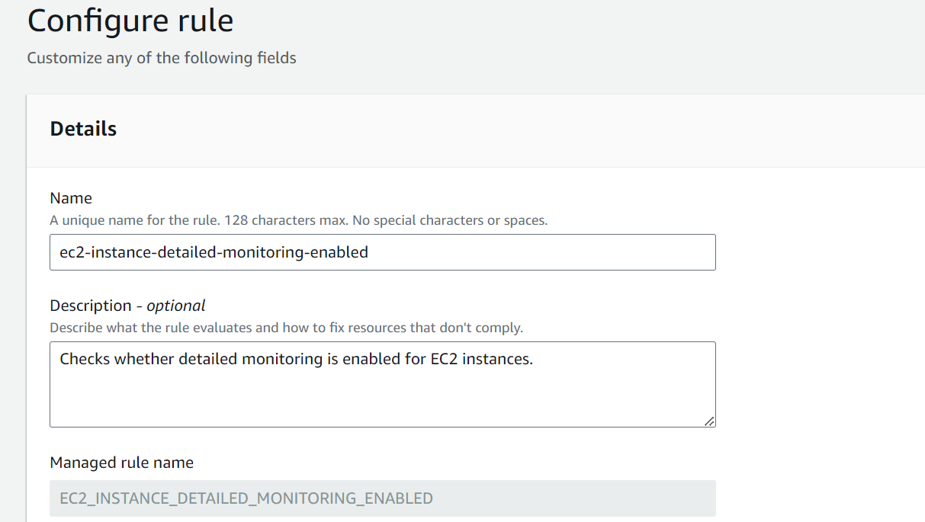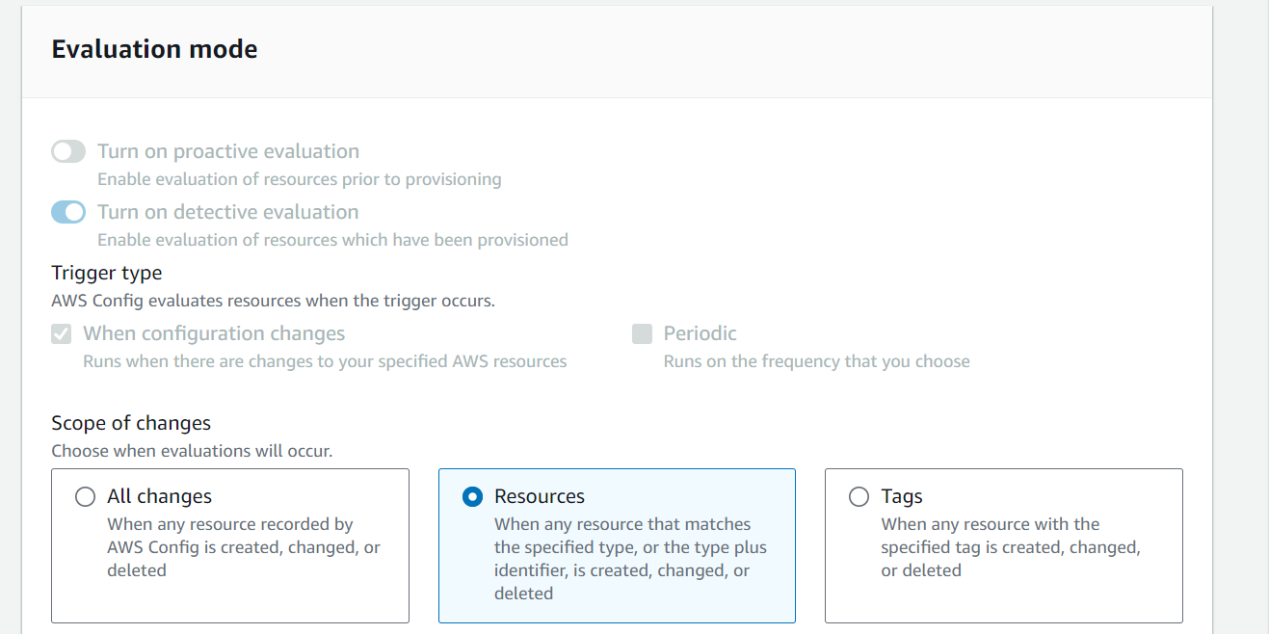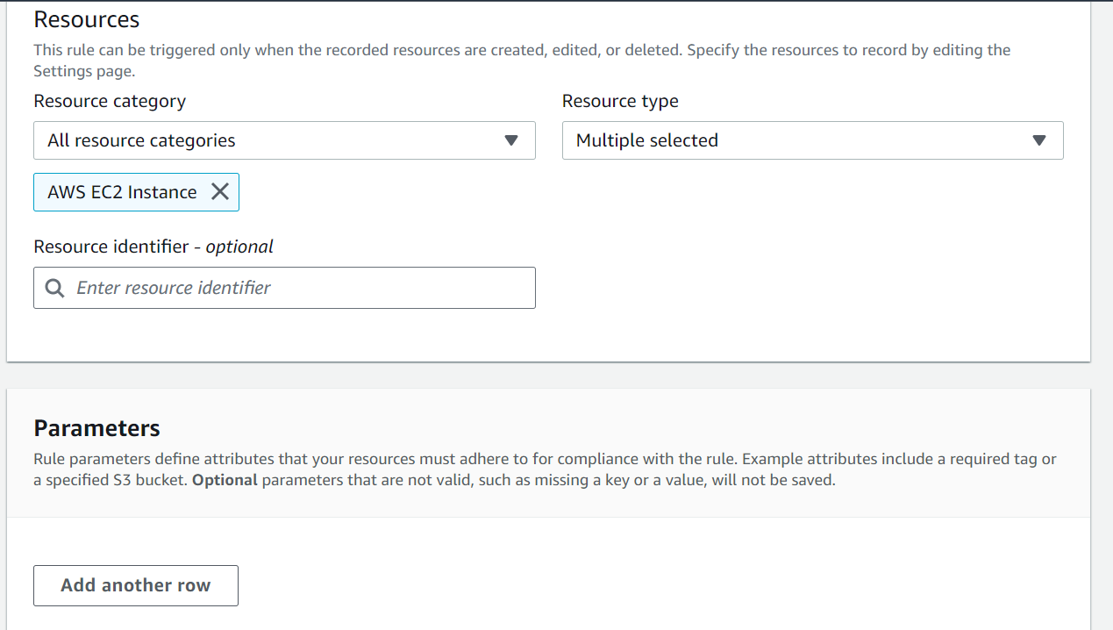
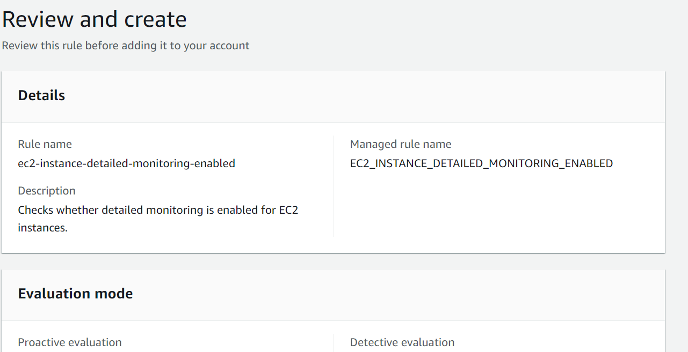
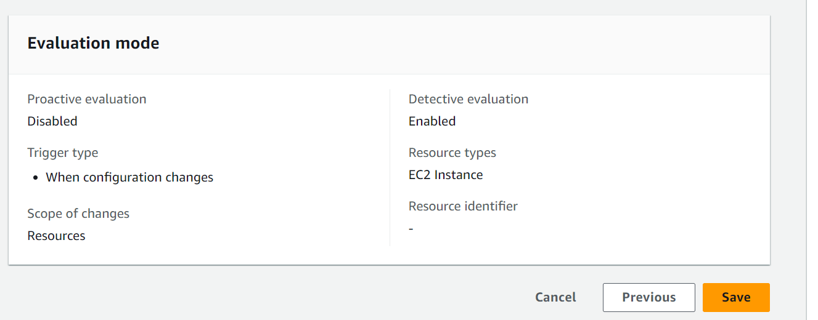
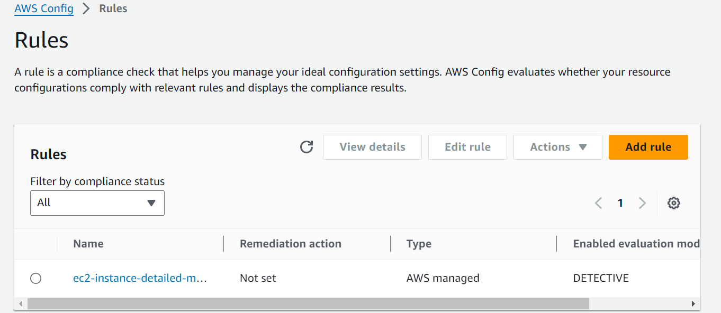

- Go to EC2 instance and create an instance without the detailed monitoring enabled. Go to this instance and check if detailed monitoring has been enabled or not
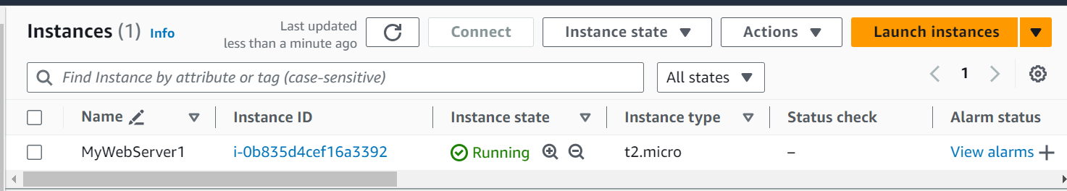
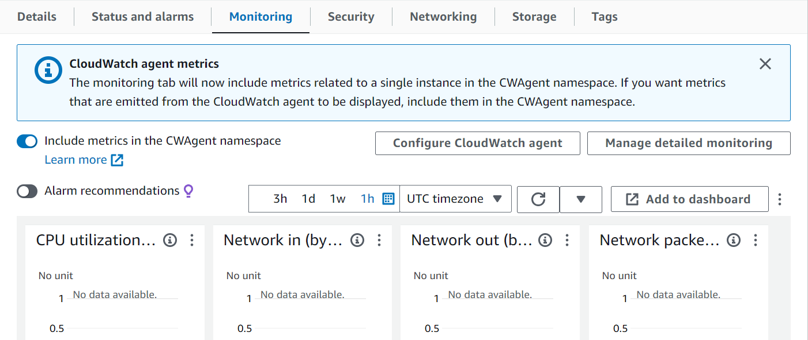
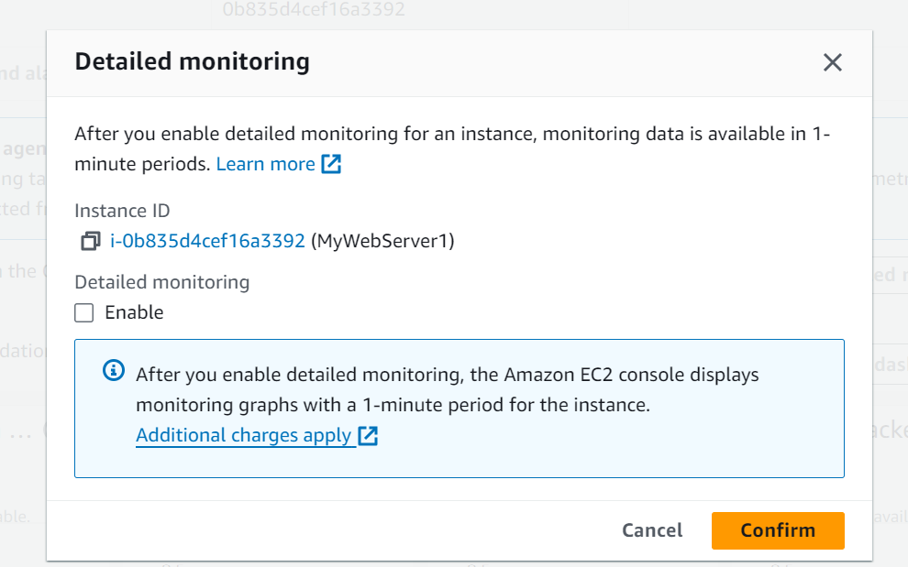
- Go to AWC Config Dashboard and check Compliance Status. You can see 1 Noncompliant rule and 1 Noncompliant resource(s). Click on 1 Noncompliant resource(s). You can see the EC2 instance which is Non-Compliant
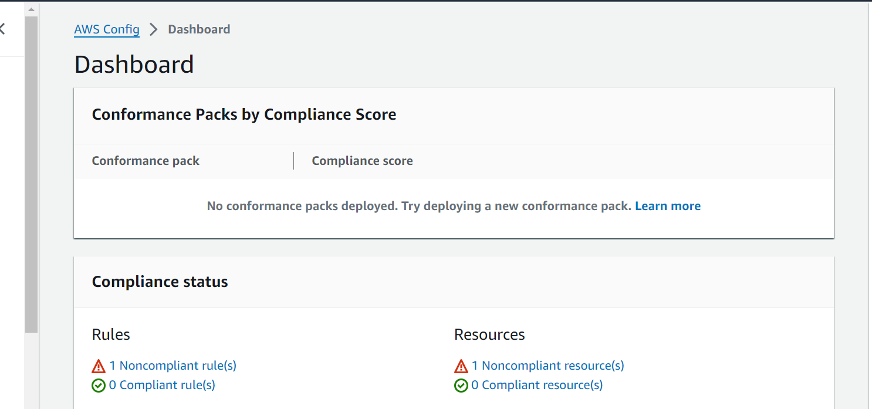
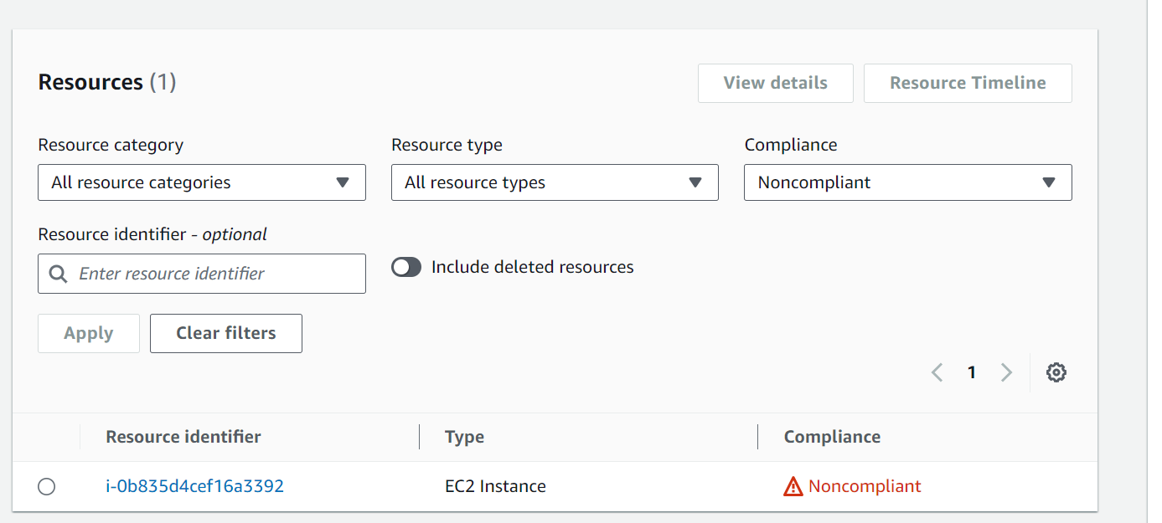
- Go back to the EC2 instance and enabled the detailed monitoring
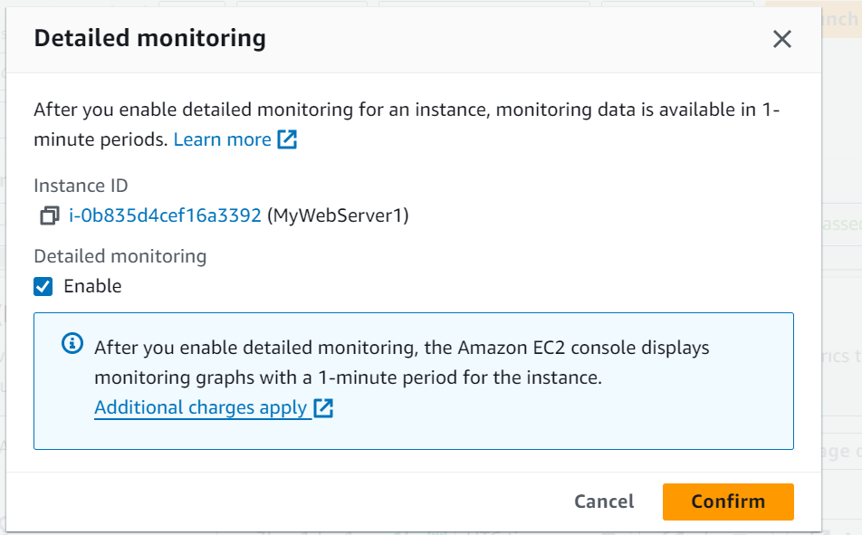

- Give some time to reflect changes in AWS Config. Now Go Back to AWS Config and check Dashboard. You can see 1 Compliant resource(s). Click on that and you can see that the same EC2 instance is compliant
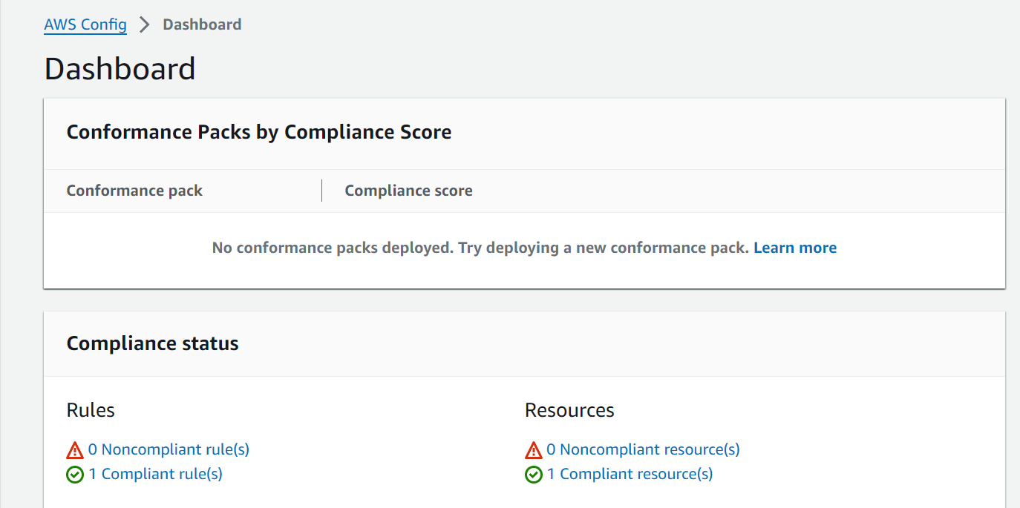
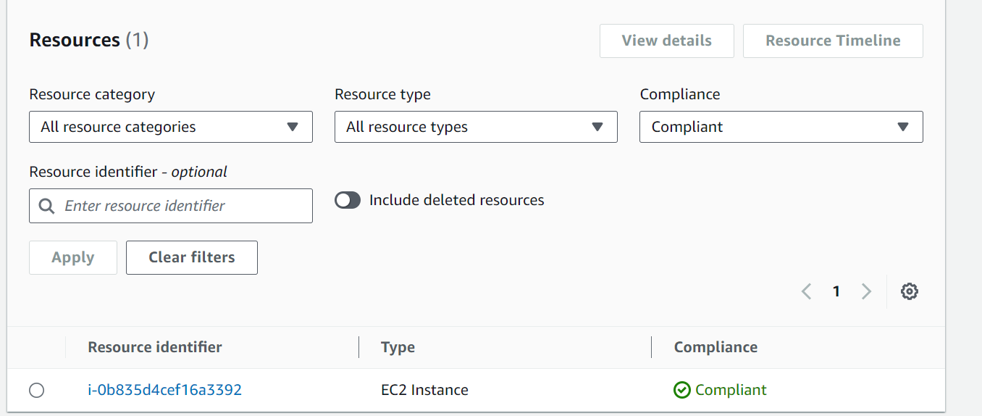

- Delete the rule, Turn Off the AWS Config recording and delete the EC2 instance
